Identificar el minimo numero de variables

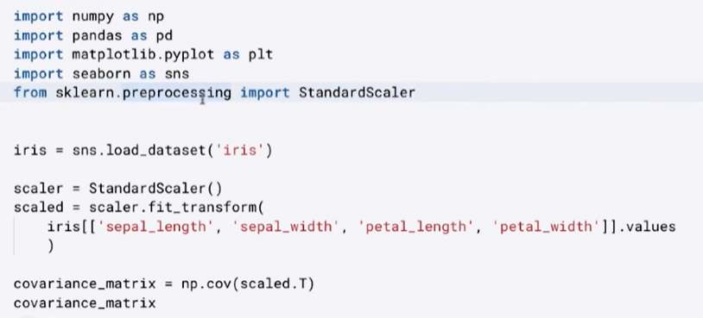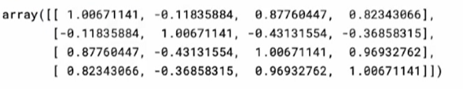

|  |  |
| --- | --- |
| sns.pairplot(iris) | sns.pairplot(iris , hue=’species’) |
|  |  |



|  |  |
| --- | --- |
|  |  |

